## MathBot – A Complete Maths Problems Solver

**Dissertation**

submitted in complete fulfilment of the requirements for the degree of

## Master of Technology

by

## Rahul Tiwari Roll No: 2303res49

under the guidance of

## Mr. Manish Kumar Acharya



2024-2025

# Acknowledgments

I express my sincere gratitude towards my guide **Mr. Manish Kumar Acharya** for his constant help, encouragement and inspiration throughout the project work. Without his invaluable guidance, this work would never have been a successful one. Last, but not the least, I would like to thank the whole **IIT Patna** family which made this program and my learnings a memorable one.

Rahul Tiwari IIT PATNA June 15, 2025

# Abstract

Like the way **elementary school** kids are taught to learn to solve **Natural Language**-based math

word problems, I have trained a gen-ai powered learning system to solve the same problems. These word problems comprise variety of topics from simple to complex level Higher-Secondary level school problems.

The goal of the system is to understand the given word problem from the language context and then provide an appropriate solution step by step for it and finally providing the final answer based on the different tools used , once the solution is provided we will try to check the correctness based on the **RLHF technique model** and if the solution provided is correct then the same solution will be provided by the Model else the MathBot will be re-trained on such problems to improve its accuracy on incorrect problems by RLHF method by re-iteration of same problems to it.

I have collected datasets of problems from various **Higher Secondary Level** school books in the form of direct text-problems and processed the same in the form of **PDFs** to create a **vector-store** out of it. Once the data is processed, I have used a **RAG** to retrieve the relevant documents from the vector store.

There have been many semantic parsers and rule-based math word problem solvers, but application of any learning algorithm to reduce **Natural Language** based math problems into equations is a

topic of recent research using **Generative-AI(LLM)** and **RAGs** to create a powerful AI Agent. In this project, I have shown that the use of **RAGs and LLMs** can help build such a **Chatbot Based learning system**.

# Introduction

Generative AI is a subset of traditional ML. The ML algorithms that work behind generative AI do so by exploiting the statistical patterns present in the massive datasets of content that was originally generated by humans. LLMs Definition LLMs (Large Language Models) are generative AI models specifically designed to understand text. All LLMs are powered by the Transformer (Google, 2017) architecture. They are designed to take in input text and repeatedly generate the next token or word that appropriately

“completes” the input text.

**For example**: an LLM can be given the input:

**Where is Ganymede located in the solar system**? **In response**, the LLM might generate the following output: Ganymede is a moon of Jupiter and is in the solar system within Jupiter’s orbit. Here, the model essentially completed the given input by repeatedly generating the next word or token that fits appropriately. These models have abilities beyond just language and can break down complex tasks, reasoning and problem solving. It is commonly accepted that as the size (in terms of number of

parameters) of an LLM increases, so does its understanding of language. At the same time, it is also true the smaller models can be fine-tuned to perform well on specific tasks

### Examples (Foundation/Base Models)

* BERT (Google, 2018)
* GPT (OpenAI, 2018)
* BLOOM (BigScience Warehouse, 2022)
* FLAN-T5 (Google, 2023)
* PaLM (Google, 2022)
* LLaMA (Facebook, 2023)

### Use Cases

* Chatbots.
* Text summary (articles, files).
* Translation (traditional human language to human language, or from natural language to code).
* Named Entity Recognition.
* More complex tasks which require invoking external tools (answering fact-based queries using Google’s Search API).

# High Level Architecture Diagram

**AI Agent Tool**

**(RAG/LLM based)**

**Streamlit Web App**

**(Problem Upload)**

**RAG Tool**

**Telegram Chatbot**

**LLM Model**

**(Google Gemma2)**

**Streamlit Web App**: The window where you can ask your problem in text format.

**Telegram Chatbot:** The base or primary model which will be trained on elementary level problems to understand and provide step by step solutions with clear explanations, it might be optional.

**AI Agent(LLM+RAG):** The LLM Model which is being used here to help in getting the correct output and if needed the output of LLM will be feedback to the Deep Learning model for re-training purpose.

# Web-App UI

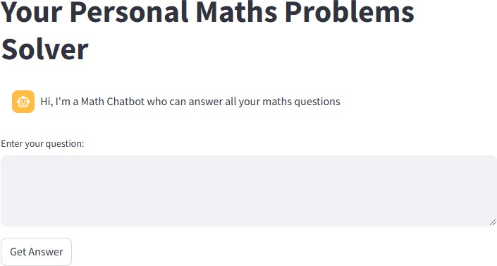

**AI Agent (LLM+RAG):** The agent which is comprised of Gemma2 Model by Google plus the RAG which is trained on elementary level problems to understand and provide step by step solutions with clear explanations.

**Current Dataset** is attached [here](https://github.com/rtiwari5317/MathBot) which I have used for RAG for retrieval purpose from **FAISS** Vector Database.

**LLM Model: Google Gemma 2** is the second generation of Google's open-source large language models (LLMs), designed to offer high performance, efficiency, and accessibility for developers and researchers which is trained with multiple parameters configurations like 2B, 9B and 27B parameters. I have used the 9b parameters configurations since it outperformed other LLM models like **Mistral 7B** and **Llama3** as well on mathematical problem solving. This has already been deployed on StreamLit Cloud Platform and is available to use for public as well. Further integrated with **Telegram** and making it a **Conversational Chatbot** which can be used by students, teachers to solve their complex problems.

**Streamlit WebApp/Telegram:** The context area or the window where the solution with clear explanations and Final Answer will be displayed. Below is the screenshot for it with sample Maths question asked to the LLM app.

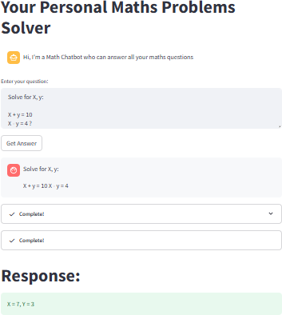

**LLM APP Link:** [MathBot - Try It YourSelf](https://mathbot-problem-solver.streamlit.app/)

**TELEGRAM Chatbot Link:** <https://t.me/Personal_Mathbot>



